# [***SVU EP: 'It's Pretty Clear' That Stabler Will Be in Season 22 Premiere***](https://tvline.com/2020/05/01/law-and-order-svu-stabler-season-22-premiere-christopher-meloni/)

By [Kimberly Roots](https://tvline.com/author/kimberly-roots/) / May 1 2020, 9:36 AM PDT

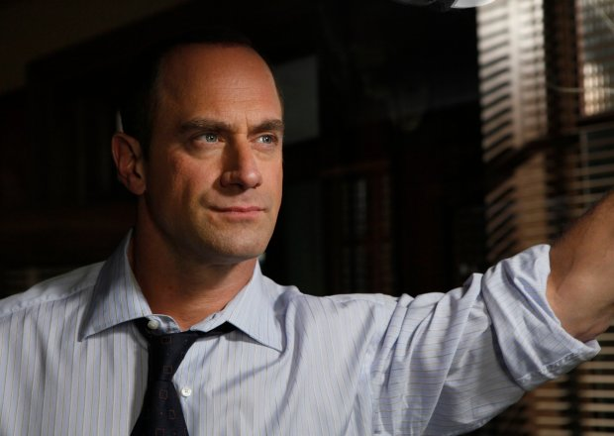

Courtesy of NBC

* [**39**](https://tvline.com/2020/05/01/law-and-order-svu-stabler-season-22-premiere-christopher-meloni/#comments)

*Law & Order* aficionados may not have to wait until the [*SVU*](https://tvline.com/tag/law-and-order-svu/) spinoff to see Elliot Stabler in action again.

In a new episode of the show’s [behind-the-scenes podcast](https://podcasts.apple.com/us/podcast/the-law-order-svu-podcast/id1480917617?i=1000473223139), *SVU* showrunner Warren Leight says, “It’s pretty clear that Elliot will be in the *SVU* season opener. I think that much I know.”

At the end of March, news broke that NBC had ordered [a Stabler-led spinoff](https://tvline.com/2020/03/31/chris-meloni-svu-returns-stabler-new-spinoff-nbc/) of the long-running procedural and that *SVU* alum Christopher Meloni would once more play the embattled New York City cop. The new series will be set in the organized crime division of the NYPD.

In April, [Leight told TVLine exclusively](https://tvline.com/2020/04/03/law-and-order-svu-season-21-stabler-chris-meloni/) that while Elliott would not have appeared in *SVU*‘s planned Season 21 finale, which was scrapped when the coronavirus breakout forced production shutdown, his wife and son *would* have.

In the podcast, Leight says whether Kathy Stabler and her kid now will show up in the premiere “remains to be seen.

“There’s a lot of moving parts,” he adds, noting that the hour would be “not just about the *SVU* season opener, it’s how do we help launch the new series, and how much crossover will there be between Elliot and Olivia as it goes on.” Essentially, he adds, the events of the jettisoned season-ender may wind up as a teaser in the first episode back… whenever that happens, given “we don’t know when we’ll be back to shooting and what shooting will be like in the post-COVID world.”

[**Memories From the Set: *Law & Order: SVU* Edition**](https://tvline.com/gallery/law-and-order-svu-photos-actors-guest-star-roles/?ref=https://tvline.com/2020/05/01/law-and-order-svu-stabler-season-22-premiere-christopher-meloni/)

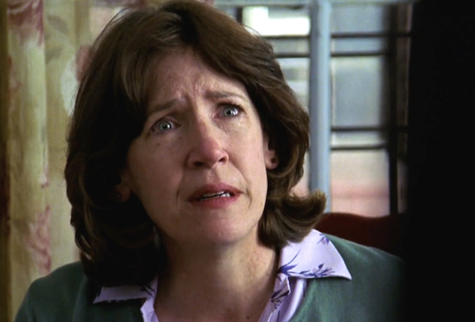

[**Launch Gallery**](https://tvline.com/gallery/law-and-order-svu-photos-actors-guest-star-roles/?ref=https://tvline.com/2020/05/01/law-and-order-svu-stabler-season-22-premiere-christopher-meloni/)

Other nuggets of *SVU* goodness dropped during the half-hour podcast include:

* More details on the circumstances that were going to bring the Stabler family back into Olivia’s orbit: “We were going to see Kathy Stabler come back, very upset — her son has been rolled by a team of ne’er-do-wells and may have been drugged.”

* A sad update on the Stablers’ home situation: One of the questions Leight said the hour would’ve addressed would’ve been “What had happened to the Stabler family after Elliot both left *SVU* and apparently left them?”

* A look into what *really* happened to Olivia’s brother: “We were going to revisit Simon’s *seeming* overdose,” Leight adds.

*SVU* faithful: What do you think of these new details? Hit the comments to discuss Season 22 and the spinoff